

MinimalCafe

A Website that Locates Available Restaurant Based on Your Needs

Software Project III - CSE316

***Submitted By:***

**Nurjahan Nowshin**

**(221-15-4632), Toki sayham shohan (221-15-5925) ,**

**Tahmina Sumaiya (221-15-5182), Mehedi Hasan Miraj(221-15-5903)**

Email: [nowshin15-4632@diu.edu.bd](mailto:murshida15-4703@diu.edu.bd) *,*[*shohan15-5925@diu.edu.bd*](mailto:shohan15-5925@diu.edu.bd) *, sumaiya1*[*5-5182@diu.edu.bd*](mailto:5-5182@diu.edu.bd) *, miraj15-5903@diu.edu.bd*

Section: 61_W

Department of Computer Science and Engineering Daffodil International University

Submitted To:

**Ms. Dristi Saha**

Lecturer

Department of Computer Science and Engineering Daffodil International University

|  |  |  |
| --- | --- | --- |
|  | **Table of Contents** |  |
| **1. Background** |  | **3** |
| **2. Motivation** |  | **4** |
| **3. Objectives** |  | **4** |
| **4. Design Specification** |  | **5-9** |
| **5. Development** |  | **10** |
| **6. Future Work** |  | **10** |
| **7. Conclusion** |  | **11** |

**Minimal_Cafe: A Website that Locates Available Restaurant Based on Your Needs**

# CHAPTER 1 BACKGROUND

Minimal_Cafe is a cozy, modern café located in the heart of downtown, offering a serene oasis amidst the urban landscape. Established in 2021 by a group of passionate food enthusiasts, this cafe has quickly become a beloved destination for both locals and tourists. The founders, driven by a profound appreciation for minimalist design and a commitment to clean, healthy eating, set out to create a space where simplicity seamlessly blends with elegance. Their vision was to develop a sanctuary where patrons could enjoy meticulously crafted dishes made from organic, locally sourced ingredients.

The interior of Minimal_Cafe is a testament to its name, featuring a minimalist design that emphasizes simplicity and functionality. The space is adorned with sleek, modern furniture made from natural materials such as wood and metal, creating a warm yet contemporary feel. The neutral color palette, consisting of whites, greys, and earthy tones, enhances the sense of calm and openness. Large windows line the walls, allowing natural light to flood the café, creating a bright and airy atmosphere that invites relaxation and reflection.

Minimal_Cafe is not just a place to eat and drink; it is a hub for community engagement and sustainability. The café hosts regular events such as yoga sessions, mindfulness workshops, and local artist exhibitions, fostering a sense of community and connection among its patrons. In line with its commitment to environmental sustainability, Minimal_Cafe employs eco-friendly practices including the use of biodegradable packaging, recycling programs, and energy-efficient appliances. By partnering with local farmers and suppliers, the café ensures the freshest ingredients while supporting the cafe ensures the freshest ingredients while supporting the local economy.

# CHAPTER 2 MOTIVATION

The motivation behind Minimal_Cafe is deeply rooted in a desire to cultivate a lifestyle that prioritizes quality over quantity. The founders observed a significant gap in the cafe market: while many places offered a variety of foods and drinks, few provided an environment that truly fostered relaxation, mindfulness, and an escape from the daily grind. They envisioned a cafe that could be more than just a place to grab a quick bite; it would be a sanctuary where customers could find peace and clarity amid the hustle and bustle of city life.

The founders of Minimal_Cafe are passionate about the principles of minimalism, which extend beyond just design into their business philosophy. The cafe menu is intentionally simple, focusing on a curated selection of high-quality, organic, and locally sourced ingredients. Each dish and beverage is crafted to highlight natural flavors, ensuring that every bite is a delightful experience without overwhelming the senses. This approach not only simplifies the decision-making process for customers but also aligns with the cafe commitment to promoting a mindful and health-conscious lifestyle.

# CHAPTER 3 OBJECTIVES

The primary objective of Minimal_Cafe is to offer a unique dining experience that emphasizes sustainability, health, and community. The cafe aims to source all its ingredients from local farmers and suppliers to ensure freshness and support the local economy. Additionally, Minimal_Cafe strives to minimize its environmental footprint by adopting eco-friendly practices such as using biodegradable packaging and reducing waste. The cafe also seeks to be a hub for community engagement by hosting events, workshops, and collaborations with local artists and entrepreneurs. Ultimately, Minimal_Cafe aspires to inspire its customers to appreciate the beauty in simplicity and to make mindful choices in their daily lives.

# CHAPTER 4 DESIGN SPECIFICATION

We used Fig-ma for designing our prototype. It is a popular tool used in UI/UX. It is a tool that helps us to create a prototype for interactive previews of our designs.

For prototype designing we used Fig-ma, because we want to make sure that our designs look good on different devices like computers, tablets, and phones. Moreover, Fig-ma works well with other Adobe programs like Photo shop and Illustrator, making it easy to use different design elements together.

It also has extra tools and features that we can add to make our work even better. One cool feature is called Repeat Grid, which makes it easy to create things that repeat, like lists or grids, saving time and effort. Overall, Fig-ma is a very helpful tool which helps us to

execute our ideas in a simple and efficient way. Here are some screenshots of our prototype:

**Home Page:**

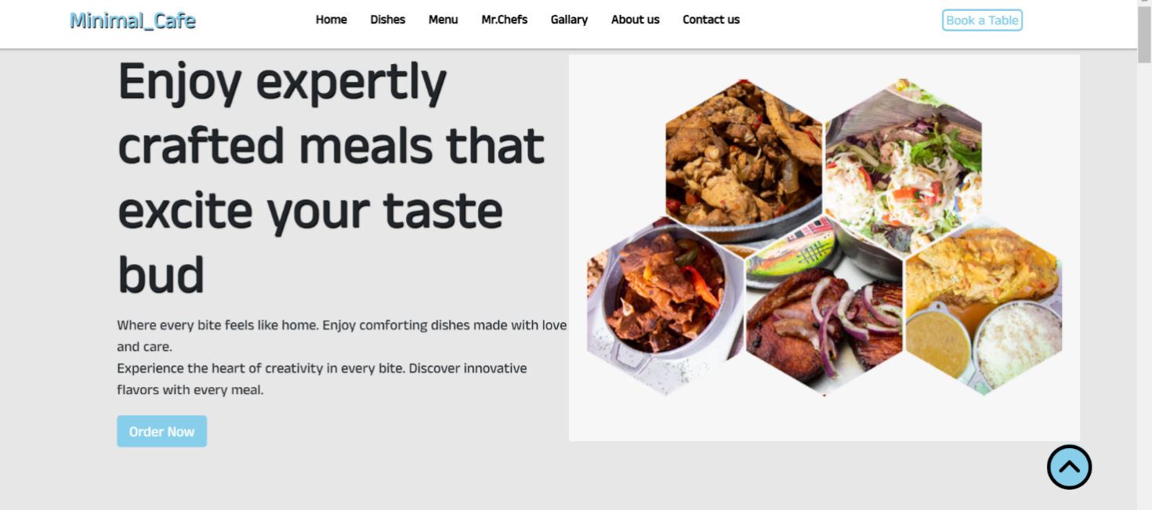

**Dishes Page:**

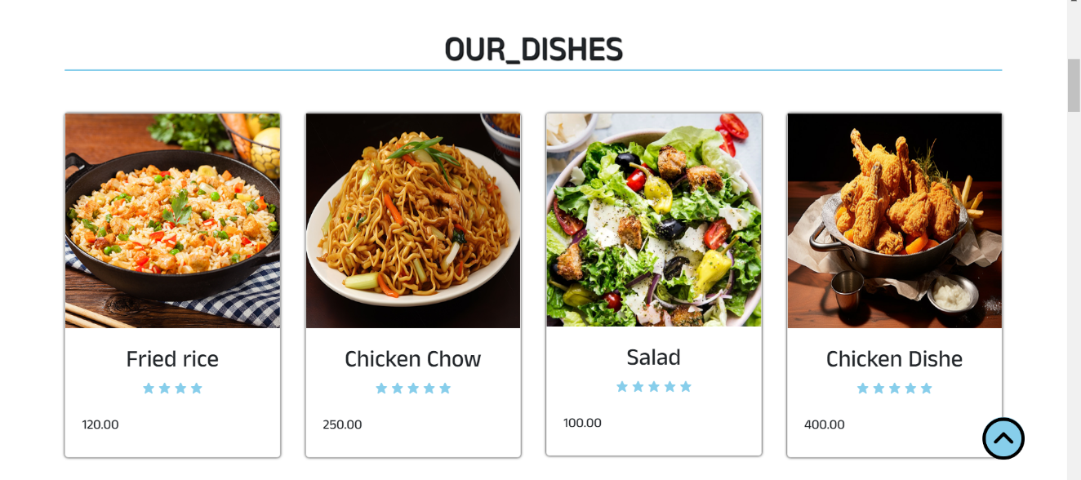

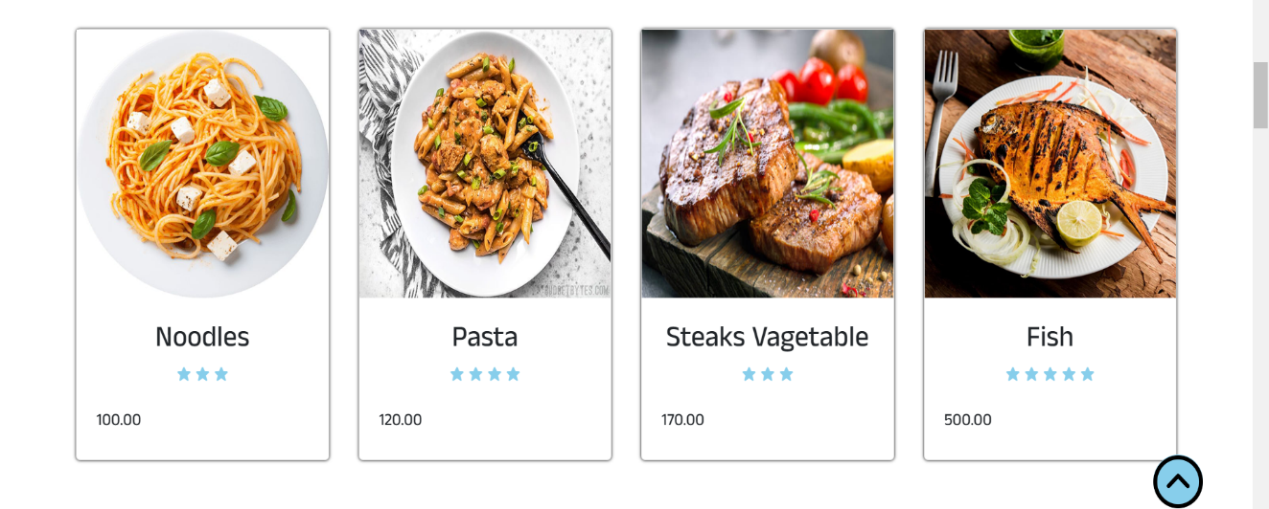

**Menu Page:**

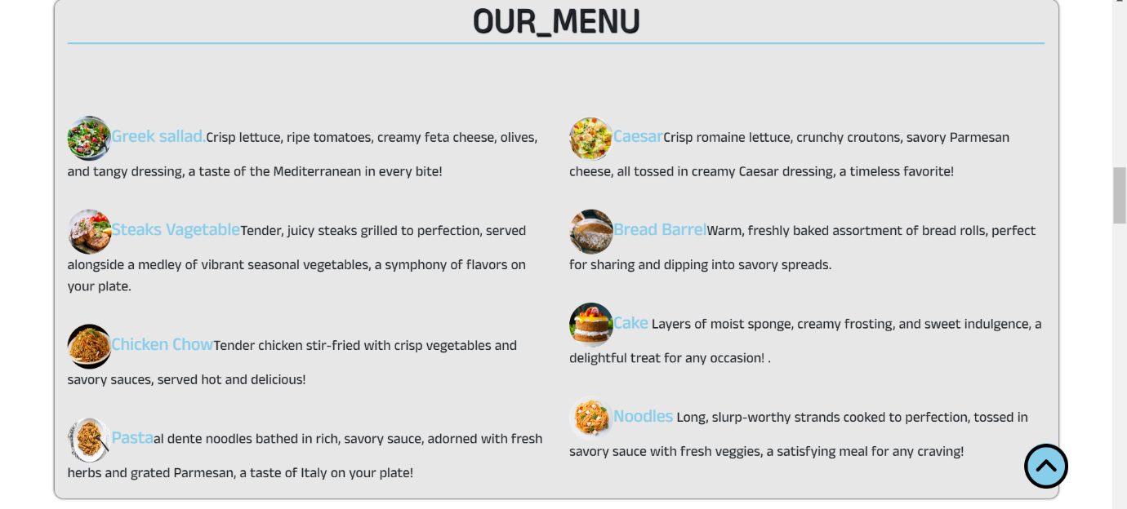

**Chef Page:**

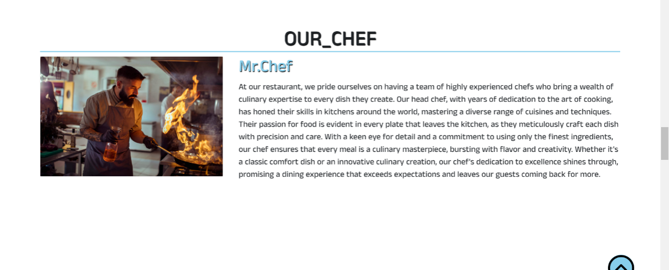

**Gallery Page:**

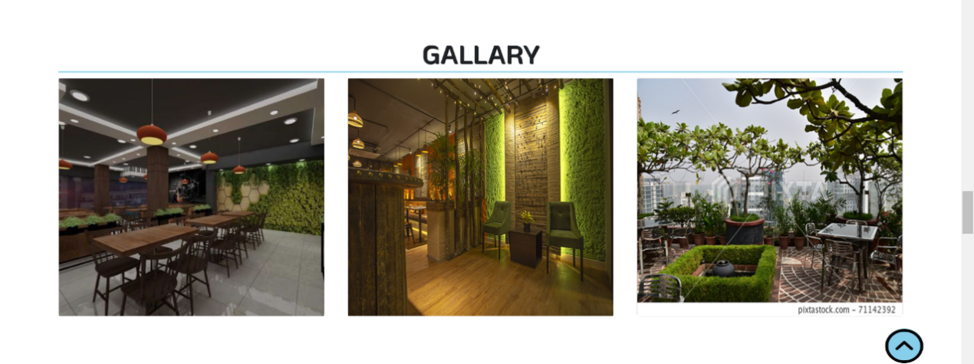

**Booking Page:**

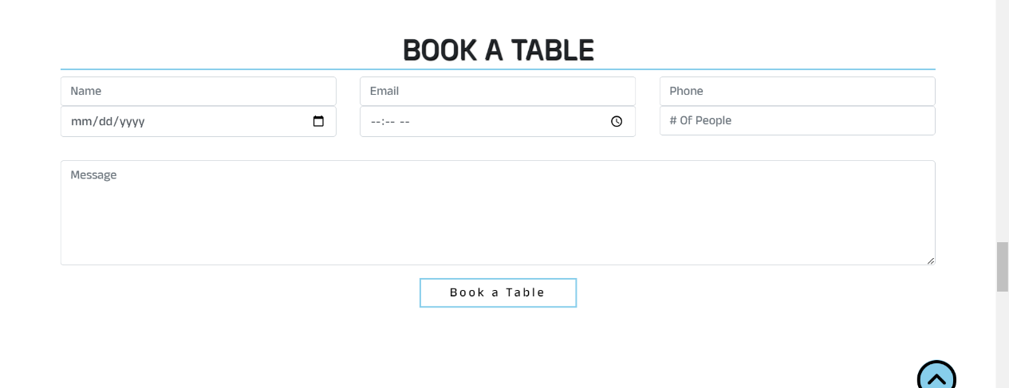

**Contact us Page:**

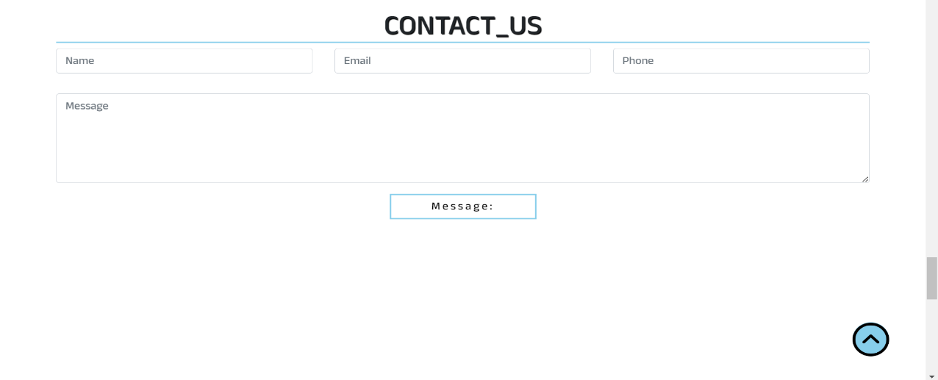

**About us Page:**

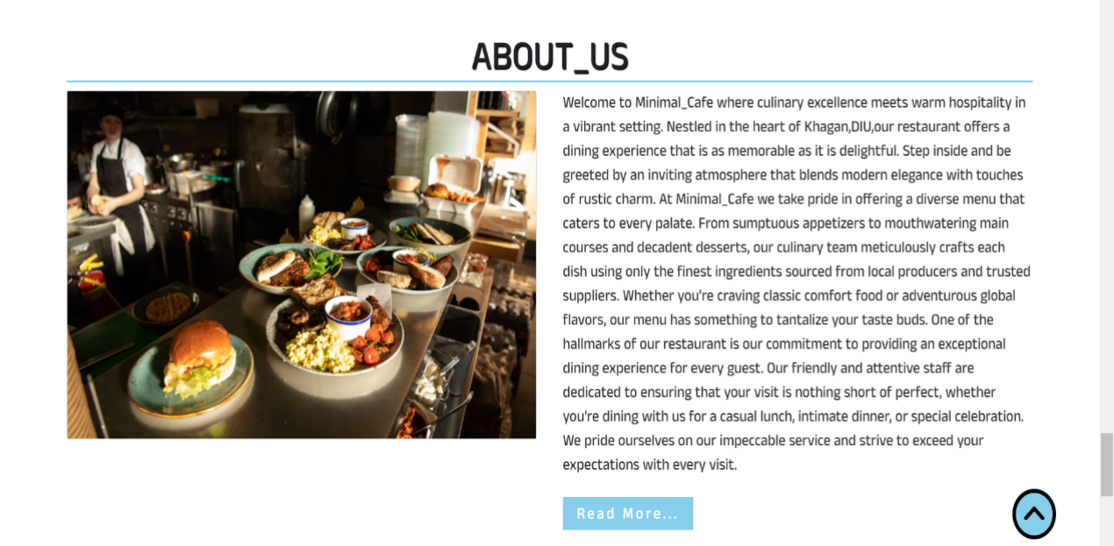

**Footer Page:**

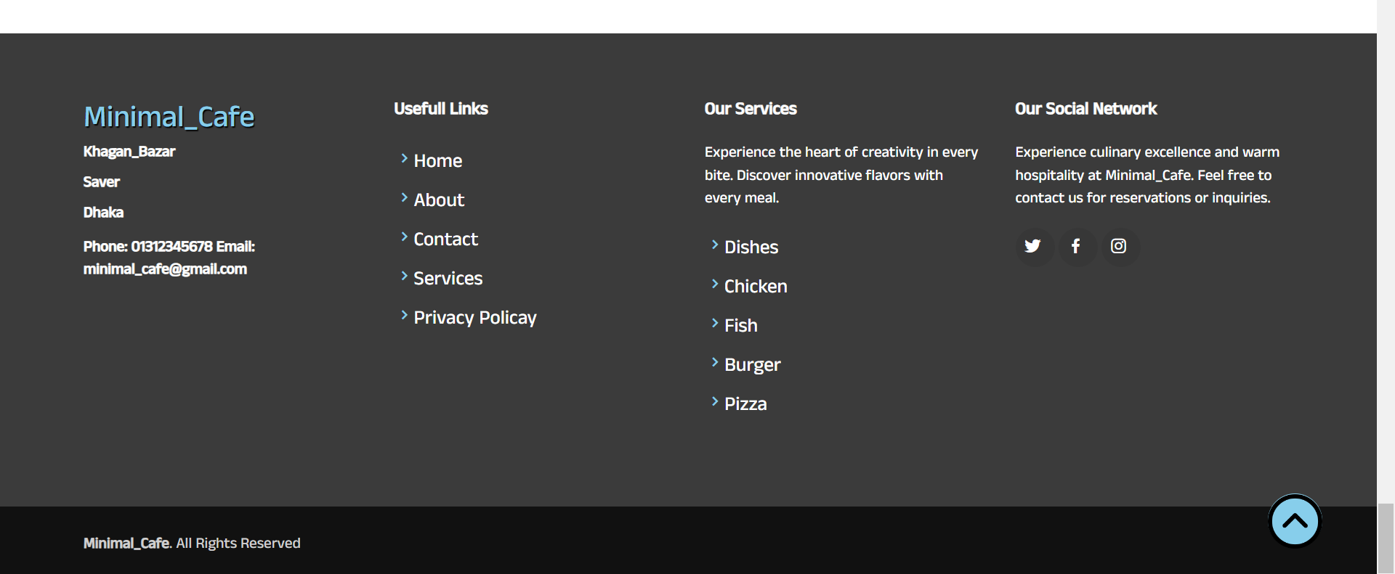

# CHAPTER 5

**DEVELOPMENT**

There are two components to an Android app or website: the front-end and the back end. The built mobile app or website's visible portion that users interact with is known as the front-end. The front-end portion of this project is designed and developed with HTML, CSS, and JavaScript.

The header-footer, home page, dishes page, menu page, and other fundamental website framework were all created using HTML in this minimal_cafe.

Next, we styled our HTML components using selectors in CSS. We adjust attributes like as colour, font-size, padding, margin, and so on to personalize the look of our website. Additionally, to expedite the style process, we leverage Sass libraries and CSS frameworks like Bootstrap.

# CHAPTER 6 FUTURE WORK

The Minimal_cafe project may see a number of significant improvements and upgrades in the future:

1. **Mobile App Development:** Developing specialized mobile apps for the iOS and Android operating systems to give parents easy-to-use, mobile access to the restaurant functions.
2. **Enhanced User Interface and Experience:** The user interface is being updated on a regular basis to make it more accessible, user-friendly, and intuitive for all users—disabled people included.

# CHAPTER 7 CONCLUSION

With the assistance of HTML, CSS, the job is completed. With a smartphone and an internet connection, users may access it from any location. Minimal_Cafe's blend of minimalist design, healthy cuisine, and community-focused ethos makes it a standout in the downtown area. Whether you're looking for a quiet place to work, a cozy spot to catch up with friends, or a haven to enjoy a moment of tranquility, Minimal_Cafe offers an experience that delights the senses and nourishes the soul. Through its dedication to simplicity and excellence, Minimal_Cafe continues to inspire and attract a diverse clientele, making it a cherished part of the city's vibrant food scene.

**GitHub Link:**

https://github.com/nurjahan-nowshin/Sp3-project-minimal-cafe-